**Marqués, René (1919-1979)**

During his lifetime, René Marqués was Puerto Rico’s most renowned literary figure. His oeuvre, which includes plays, short stories, essays, film scripts, poetry, and a novel, shows deep concern with the destiny of Puerto Rico and its colonial relationship with the United States. Marqués’s cultural conservatism—reflected in his nostalgia for a paternalist and agrarian past—has been rejected by subsequent generations of intellectuals. However, from the 1950s-70s, his role as a provocateur in politics and the arts solidified the status of the writer as a social critic and professional in Puerto Rico. At the same time, his constant experimentation with literary techniques established him as the exemplary modernist writer of his generation.

René Marqués was born and raised in Arecibo, surrounded by a family that instilled in him a passion for the land, national independence, and art. After earning his college degree in 1942, he worked for two years as an agronomist in the Department of Agriculture. In 1946, he studied literature in Spain, and in 1949, a Rockefeller Foundation fellowship allowed him to pursue theatre training in New York City at Columbia University and Erwin Piscator’s Dramatic workshops. He wrote his first plays in the 1940s and became a true man of the theatre by directing, producing, writing criticism, and helping to found groups such as Teatro Nuestro (Our Theatre) in 1950 and the Experimental Theatre of the Puerto Rican Athenaeum in 1951. During this period he also began work in the Department of Education’s community education program as a writer and head of the publishing section.

Marqués’s reputation as a playwright was established with *La carreta* [*The Oxcart*] (1952), which documents the plight of a rural family, who, unable to pay the mortgage on their land, migrates from the mountains to a slum in the capital and then to New York, where their dreams of a better economic future are destroyed by the degradation of their traditional values in the mechanized, industrial world of the city. Similarly tragic, but inventive in its use of flashbacks, lighting, and music, is Marqués’s other most frequently staged work, *Los soles truncos* [*The Fanlights*] (1958). In this poetic and symbolic piece, three spinster sisters of the landed creole class reject contemporary Puerto Rican society and attempt to retain the purity of their European ancestry by secluding themselves in their dilapidated colonial home. When it becomes apparent they can no longer avoid contact with modernity and the outside world, the sisters commit suicide by setting their mansion on fire.

1958 marked a high point for Marqués. *The Fanlights* was selected for staging at the first Puerto Rican Theatre Festival, and he won first prize in the Puerto Rican Athenaeum literary competition in four genres: short story, novel, essay, and drama. In the 1960s, Marqués incorporated absurdist themes and techniques with increasing intensity in *La casa sin reloj* (The House Without a Clock), *Carnaval afuera, Carnaval adentro* *(*Carnival Outside, Carnival Inside*)*, and *El apartamiento* (The Apartment). These plays experiment with absurdist parable, grotesque distortion, and ritual games, yet as in other examples of the Latin American theater of the absurd, the absurdity of the human condition they reveal is not purely existential but is instead linked to concrete socio-political circumstances—in this case, the dependent commonwealth status of Puerto Rico. It is only in Marqués’s lesser-known final works—biblical parables—that his nationalist stance becomes difficult to discern.

Marqués experimented with literary techniques and stage craft to communicate his nostalgia for an idealized rural lifestyle and his consternation with the economic and social dislocation produced by United States imperialism. From allegory, pantomime, naturalistic-realism, tragedy, expressionism, theater of the absurd to historical drama, Marqués never ceased to rehearse dramatic styles. A cultural traditionalist and formal innovator, he advanced the technical standards of poetry and prose on his island and embodied a modern notion of professionalism in Puerto Rican theatre and letters.

**List of Works**

Marqués, René. (1970-71) *Teatro. Tomo. 1. Los soles truncos; Un niño azul para esa sombra; La muerte no entrará en palacio. Tomo 2. El hombre y sus sueños; El sol y los Mac Donald. Tomo 3. La casa sin reloj; El apartamiento.* Río Piedras: Editorial Cultural.

--------- (1969) *The Oxcart,* trans. Charles Pilditch, New York: Scribner.

---------- (1971) *The Fanlights*,trans. Richard John Wiezell in *The Modern Stage in Latin America*, ed. George W. Woodyard, New York: Dutton.

--------- (1971) *Carnaval afuera, carnaval adentro,* Río Piedras: Antillana.

--------- (1976) *The Docile Puerto Rican: Essays*, trans. Barbara Bockus Aponte, Philadelphia: Temple University Press.

--------- (1983) *The Look* (translation of novel *La mirada*), trans. Charles Pilditch, New York: Senda Nueva de Ediciones.

**Further Reading**

Díaz, Quiñones, Arcadio. (1982) *El almuerzo en la hierba*, Río Piedras: Ed. Huracán.

Hildebrand Reynolds, Bonnie. (1988) *Space, Time, and Crisis: The Theater of René Marqués*, York, South Carolina: Spanish Literature.

Holzapfel, Tamara. (1976) “The Theater of René Marqués: In Search of Identity and Form” in Leon F. Lyday and George William Woodyard (eds.), *Dramatists in Revolt: The New Latin American Theater*, Austin: University of Texas Press.

Martin, Eleanor J. (1979) *René Marqués*,Boston: Twayne.

Stevens, Camilla. (2004) *Family and Identity in Contemporary Cuban and Puerto Rican Drama*, Gainesville: University Press of Florida.

**Camilla Stevens, Rutgers University**

**IMAGES**

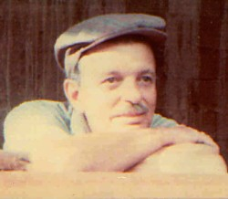

[www.prpop.org](http://www.prpop.org/noticias/mar06/soles_truncos_mar18.shtml)

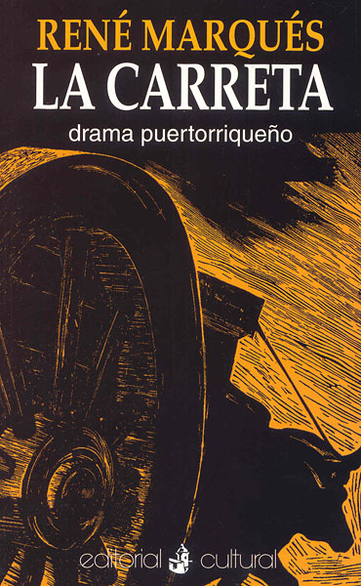

[www.encaribe.org](http://r.search.yahoo.com/_ylt=AwrB8pC.YCdTb0UAl6GjzbkF;_ylu=X3oDMTBtdXBkbHJyBHNlYwNmcC1hdHRyaWIEc2xrA3J1cmw-/RV=2/RE=1395118398/RO=11/RU=http%3a%2f%2fwww.encaribe.org%2fes%2farticle%2frene-marques-garcia%2f1096/RK=0/RS=H6tvxtGdIbdXNt1e9HIfDjLtKVM-)

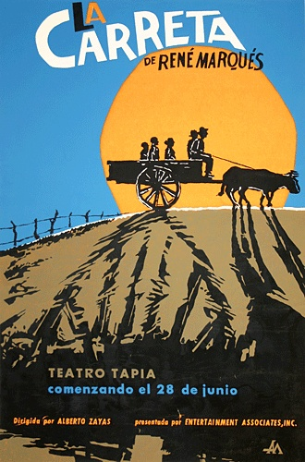

[www.pinterest.com](http://www.pinterest.com/pin/110830840799544266/)